|  |  |
| --- | --- |
| cetlogo ***CHEMICAL ENGINEERING TRANSACTIONS***  ***VOL. 92, 2022*** | A publication of  aidiclogo_grande |
| The Italian Association  of Chemical Engineering  Online at www.cetjournal.it |
| Guest Editors: Rubens Maciel Filho, Eliseo Ranzi, Leonardo Tognotti  Copyright © 2022, AIDIC Servizi S.r.l.  **ISBN** 978-88-95608-90-7; **ISSN** 2283-9216 | |

Technoeconomic Analysis of Dual Oil and Biochar Production from Creole Avocado in North-Colombia

Tamy Herrera-Rodríguez, Vianny Parejo-Palacio, Ángel González-Delgado\*

Nanomaterials and Computer Aided Process Engineering Research Group (NIPAC), Chemical Engineering Department,

Faculty of Engineering, University of Cartagena, Av. del Consulado Calle 30 No. 48-152, Cartagena, Colombia.

agonzaled1@unicartagena.edu.co

Creole avocado (*Laurus Persea L*) presents a high potential of valorization since seed and pulp can be used for obtaining high value products. The fruit is composed of pulp, seed, and peel, the avocado pulp is used mainly for human consumption, but it can also be used to obtain oils, pastes, and creams, as it is rich in proteins, fats, and carbohydrates; the rest are generally discarded. The avocado seed has a composition rich in fatty acids, polyphenols, and alkaloids, which allows it to be used to obtain bioplastics, dyes, animal feed, among others. This part of the avocado represents approximately 16 % of the total weight of the fruit. In the present study, the production of oil and charcoal (biochar) from avocado pulp and seed, respectively, was economically evaluated. The process is new and untested with a useful life of 15 years, with a processing capacity of 10,500 t/y and a product flow of 1,505 t/y. A total capital investment of $ 7,699,270.14 was obtained and a recovery of the investment of 6.67 years. In addition, a cost-benefit ratio greater than 1 was obtained, indicating that the project should be considered because the benefits are greater than the costs.

* 1. Introduction

Agricultural and forestry crops produce a large amount of waste during processing, 18 % of the avocado crop corresponds to residues, 20 % of these is the seed (Poveda et al., 2021). Colombia is one of the largest avocado producers in Latin America, in 2018 the country produced more than 500 metric tons of this fruit, representing 6 % of world production (Solarte et al., 2021). According to DANE (2015), 75 % of the avocados produced in the country belong to the Antillean race (*Persea Americana var. Americana*) divided into the Lorena (*Lauraceae*) and Creole varieties. In the Montes de María, in northern Colombia, deterioration of avocado fruits has been observed due to the presence of fungi, damage during transport, or due to marketing strategies (Burbano, 2019), increasing the generation of waste. The use of this type of biomass is important to obtain value-added products by applying the biorefinery concept, in this way the effects on the environment caused by final disposal methods are mitigated (Poveda et al., 2021).

The products that are mostly obtained from avocado are guacamole and avocado oil, the latter having properties similar to those of olive oil. Obtaining the aforementioned products generates large amounts of seed and shell waste, reducing the sustainability of the process (Solarte et al., 2021). The oil can be obtained by applying various techniques, including extraction with organic solvents such as hexane, chloroform, ethanol, ethyl ether, among others (Corzzini et al., 2017). The solvent extraction method is the most used because it improves the yield of the oil, generally, the product obtained is used in the cosmetic industry (Perez et al., 2021). In addition, to take advantage of the avocado seed, charcoal can be obtained, which is produced mainly from pyrolysis, carbonization, or gasification of biomass (wood, grass, or residues such as the shells of different foods and sawdust). The characteristics of biochar depend on the type of substrate and the generation methods, the most common to produce it is through biomass pyrolysis, a technique in which the temperature must be controlled to ensure the characteristics of the material and its performance (Van et al., 2021). In the present study, the assembly of a plant in northern Colombia for the production of oil and biochar from avocado pulp and seed, respectively, was evaluated from a technical-economic point of view. The oil is obtained by solvent extraction and the biochar by pyrolysis. For the evaluation and economic sensitivity, it was necessary to determine prices of equipment, raw materials, labor, type of land, among other characteristics of the process.

* 1. Materials and methods

2.1 Process description

The oil is obtained by extraction with hexane (solvent), while the biochar is produced from pyrolysis, figure 1 shows the block diagram of the process. The process begins with washing the fruit with a solution of NaClO (stream 2) to remove impurities, the clean avocado is peeled and pulped, separating the peel (stream 6) and the seed (stream 8), which are sent to washing stages to recover the remaining pulp (streams 10 and 13), these send to a centrifugation stage to eliminate the water present. The extracted pulp (stream 7) and the pulp resulting from centrifugation (stream 17), are homogenized to form a paste that is subsequently dehydrated to remove the moisture present in it. Pulp drying is carried out at a temperature of 70 °C and 1 bar of pressure (Ariza et al., 2011). The dehydrated pulp (stream 21) is put in contact with hexane to extract the avocado oil, then in the centrifugation stage, the suspended solids are removed, obtaining a residual pulp (stream 24) and an oil-solvent mixture (stream 25), which goes through a flash distillation where the oil (stream 27) is separated from the hexane, the latter is condensed and recirculated to the oil extraction stage.

From washing the seed to removing the remaining pulp, stream 11 is obtained, corresponding to the clean seed. This is sent to a mill to reduce its size and facilitate the reduction of moisture during drying. The dehydrated seed (stream 35) is sent again to a mill to reduce the particle size of the material, then stream 37 is sent to a sieve to recirculate the material (stream 38) that does not have the right size to the mill and the resulting it is sent to the pyrolysis stage where the biochar (stream 41) and gases are obtained, the gases are condensed for later treatment. The pyrolysis reactor worked at 400 °C, a temperature at which a greater conversion of biomass into biochar is obtained, it was also fed 100 cm3/min of nitrogen to guarantee an inert atmosphere inside it to obtain the desired amount of sample (Durak and Aysu, 2014). The simulation and design of the process were carried out in Aspen Plus, this software provides the mass balance and therefore yields of each product. The plant has a processing capacity of 10,605 t/a, obtaining 1,000.67 t/a of avocado oil and 505 t/a of biochar.

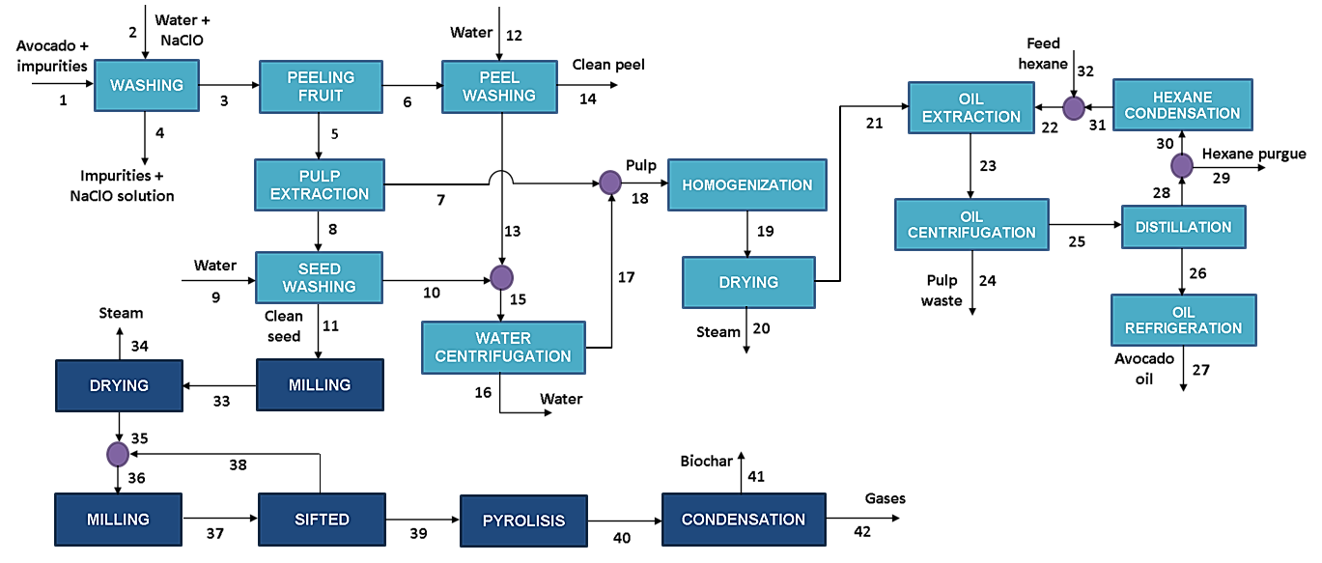

Figure 1: Process flow diagram of dual Oil and Biochar production from creole avocado.

2.2 Economic analysis

For the assembly of a plant to obtain avocado oil and biochar, it was necessary to collect information about the equipment prices, industrial services, labor, taxes, type of soil, as well as apply equations that allow evaluating the behavior of the process from an economic point of view (Romero et al., 2017). The total capital investment is calculated with Eq. (1), where FCIs is the money needed to make payments for equipment, civil structures, land preparation, control system, facilities, among others. The WCI corresponds to the working capital investment and the SUC to the start-up costs, such as legal expenses, advertising, employee training. On the other hand, the necessary expenses to have the plant in operation are calculated through Eq. (2). Annualized fixed costs are determined using Eq. (3). If the operating costs are given per unit of product, Eq. (4), corresponds to the normalized total operating costs. Likewise, Eq. (5) represents the total annualized costs for a process.

|  |  |
| --- | --- |
| $$TCI=FCI+WCI+SUC$$ | (1) |
| $$OC=DPC+FCH+POH+GE$$ | (2) |
| $$ACF=\frac{FCI_{0}-FCI_{S}}{N}$$ | (3) |
| $$NOC=\frac{AOC}{m_{RM}}$$ | (4) |
| $$TAC=ACF+AOC$$ | (5) |

Concerning the indicators, equations are used that allow knowing the behavior of the process, because the recovery time of the investment is identified, operating breakeven point taking into account the processing capacity of avocado, and the changes in the price. of the same. Eq. (6) is applied to calculate the real profit of a project, after having paid taxes, interests, loans. With Eq. (7) the gross profits of the process are determined with depreciation included, likewise, the CCF or relationship between the profits of a process for the capital investment is calculated through Eq. (8), for a process to be attractive this ratio must be less than 1.

|  |  |
| --- | --- |
| $$PAT=DGP\left(1-itr\right)$$ | (6) |
| $$DGP=\sum_{i}{m_{i}C_{i}^{v}-TAC }$$ | (7) |
| $$CCF=\frac{\sum_{i}{m_{i}C_{i}^{v}}-AOC}{TCI}$$ | (8) |
| $$PBP=\frac{FCI}{PAT}$$ | (9) |
| $$\%ROI=\frac{PAT}{TCI}x100\%$$ | (10) |
| $$NPV=\sum_{n}{{{AFC}_{n}(1+i)}^{-n} }$$ | (11) |
| $$ACR=NPV \left(\frac{i{(1+i)}^{n}}{{(1+i)}^{n}-1}\right)$$ | (12) |

Another indicator is the payback period and is calculated by applying Eq. (9). Furthermore, it is possible to determine the return on investment with Eq. (10), considering the value of money over time. Eq. (11) is used to calculate the Net Present Value; this is the sum of all the profits accumulated in the periods of operation of the plant. Finally, the cost-benefit ratio of a project is determined by Eq. (12).

2.3 Technoeconomic analysis

For the assembly of the oil and biochar production plant from avocado, some considerations were made as shown in table 1. These were established according to local conditions and based on the total production of avocado in the region, 30 % was taken as processing capacity, that is, 10,500 t/y. The plant uses avocados that are discarded, producing 1,505 t/y between oil and biochar. The economic analysis considered a useful life of the plant of 15 years, an income tax rate of 32 % (Acero and Barone, 2019), and an interest rate of 8.3 % (The World Bank, 2020) for the year 2020. A contingency value of 30 % was established, that is, money that can be used for contingencies such as strikes, design changes, price changes, and floods. The costs of raw materials were consulted through suppliers (www.alibaba.com), also taking into account the prices in the market, the price of the products was set.

Table 1: Technoeconomic assumptions for oil and biochar production from creole avocado

|  |  |
| --- | --- |
| Processing capacity (t/y) | 10,500 |
| Main product flow (t/y) | 1,505 |
| Avocado ($/t) | 36 |
| Avocado oil ($/kg) | 20 |
| Avocado biochar ($/kg) | 3.0 |
| Salvage value | 10 % of depreciable FCI |
| Construction time of the plant | 3 years |
| Type of process | New and unproven |
| Process control | Digital |
| Project type | Plant on non-built land |
| Soil type | Soft clay |
| Tank design code | (ASME) |
| Specification diameter vessels | Internal diameter |
| Salary per operator ($/h) | 30 |
| Number of workers per shift | 15 |

* 1. Results and discussion

Table 2 shows the results of the economic evaluation, such as costs of the land, pipes, contractor fees, construction expenses, among others. In addition, the price of the equipment necessary for the operation and assembly of the plant in northern Colombia. The biochar obtained can be used to improve soil properties, according to Crowley (2012), adding biochar to the soil increases the cation exchange capacity and stabilizes the organic carbon present in soils that contain pyrolyzed carbon. While avocado oil is used in the cosmetic industry for personal care and the pharmaceutical industry for dermatological medical treatments (Monsalve and Ramos, 2019).

Table 2: Total capital investment for oil and biochar production plant from creole avocado (by the authors)

|  |  |
| --- | --- |
| **Costs of capital investment** | **Total (US$)** |
| Delivered purchased equipment cost | 1,106,870.60 |
| Purchased equipment (installation) | 221,374.12 |
| Instrumentation (installed) | 88,549.65 |
| Piping (installed) | 221,374.12 |
| Electrical (installed) | 143,893.18 |
| Buildings (including services) | 442,748.24 |
| Services facilities (installed) | 332,061.18 |
| **Total DFCI** | 2,556,871.09 |
| Land | 110,687.06 |
| Yard improvements | 442,748.24 |
| Engineering and supervision | 354,198.59 |
| Construction expenses | 376,336.00 |
| Legal expenses | 11,068.71 |
| Contractors' fee | 178,980.98 |
| Contingency | 332,061.18 |
| **Total IFCI** | 1,972,111.35 |
| **Fixed capital investment (FCI)** | 4,528,982.43 |
| Working capital (WC) | 2,717,389.46 |
| Star tup (SU) | 452,898.24 |
| **Total Capital Investment (TCI)** | **7,699,270.14** |

3.1 Economic indicators

Table 3 presents the results of the economic indicators for the production of avocado oil and avocado seed biochar under specific assumptions. It can be seen that the return-on-investment rate and the annual cost-revenue were calculated at 43 % and 7.42, respectively. Therefore, the larger the more attractive the project will be. Since the cash flow is less than 1, the assembly of the biomass utilization plant (residues from the avocado crop or damaged fruits) should be considered. Homagain et al. (2016) studied the assembly of a biochar-based bioenergy system, obtaining an ROI of 9 % with a payback time of the investment at the end of 12 years. In the biochar and biofuel production process, Campbell et al. (2018) obtained financial losses with a net present value of -24.3 E+06 $. While for the production of only biochar, it obtained a net present value of 41.5 E+06 $. For their part, Solarte et al. (2021) proposed different scenarios to evaluate avocado biorefineries in Montes de María. The selected small-scale biorefinery has a return on investment in the sixth year and an NPV of 210,000 USD. In contrast, the large-scale biorefinery showed a net present value of 0.25 M.USD and a return on investment after 19.64 years of plant operation. In this case, avocado oil, furfural, and levulinic acid are produced as value-added products.

Table 3: Economic indicators for dual oil and biochar production plant from creole avocado

|  |  |
| --- | --- |
| **Costs of capital investment** | **Total (US$)** |
| Gross Profit (depreciation not included) (GP) | 5,162,674.49 |
| Gross Profit (depreciation included) (DGP) | 4,868,121.46 |
| Profit After Taxes (PAT) | 3,310,322.60 |
| Cumulative cash flow (CCF) (1/year) | 0.67 |
| Payback period (PBP) (years) | 1.37 |
| Discounted payback period (DPBP) (years) | 6,67 |
| %ROI | 43.00 % |
| NPV (MM$) | 62.32 |
| **Annual cost/Revenue** | 7.42 |

These results indicate that a higher input of raw material is required to obtain more income. It should be noted that the small-scale biorefinery produces avocado oil, animal feed, and biogas, while in the present process only the assembly of a plant for the production of oil from avocado pulp and biochar from the seed was evaluated. of this same fruit, obtaining an NPV of 62.32 MM$ and an investment payback period time of 6.67 years.

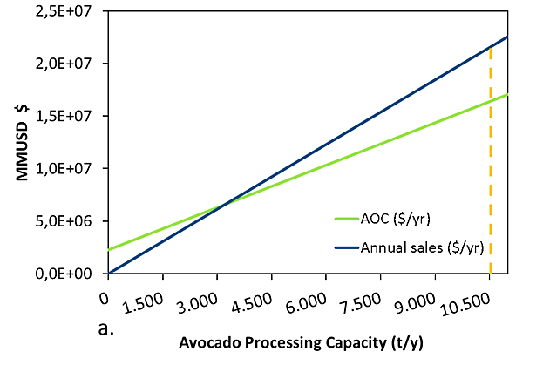 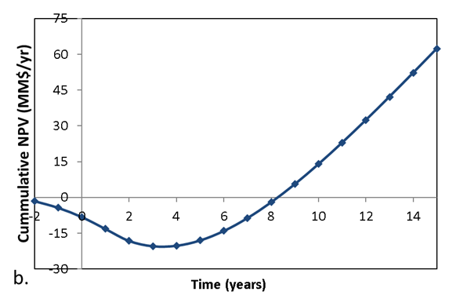

Figure 2: a) Equilibrium production capacity. b) Net Present Value of the process.

The economic analysis allowed us to evaluate how the avocado oil and biochar production process could be affected, if there are changes in the product's sale price, in the cost of the raw material. Figure 2a shows that the installed capacity of 10,500 t/y is far from the equilibrium point, so the process will not be affected if its processing capacity decreases. An equilibrium production capacity of 3,200 t/y was obtained, represented by the intersection of the two lines. Figure 2b represents the sum of all the profits accumulated during the useful life of the plant (15 years), the process begins to have a positive net present value from the eighth year, after this period it is possible to recover the investment made by taking into account the change in the value of money over time. Because the benefits are greater than the investment and costs, the project is viable from the economic point of view (Riveros and Leal, 2016). To determine the sustainability of the process, it is necessary to evaluate the process not only from the economic point of view but also from the environmental, exergetic, technical, and safety points of view.

4. Conclusions

Being the assembly of an oil and biochar production plant, a new and untested process, good results were obtained for the use of residual biomass from the avocado crop. It was observed that the process will not be affected by changes in the price of the raw material, since the avocado used will not increase its value significantly, likewise, the present study allowed identifying the costs associated with the purchase and installation of equipment, assembly of structures, industrial services, labor and other expenses. The indicators help define the viability of a project, in this case, the technical-economic analysis yielded favorable results since a positive % ROI and a cost-benefit ratio greater than 1 are obtained, indicating that it is possible to invest in the assembly of a plant. north of Colombia with the above considerations. In addition, the process has a positive net present value and a payback of the investment in almost 7 years.

Nomenclature

FCI – Fixed capital investment

FCI0– Initial value of depreciable Fixed Capital Investment

FCIs – Salvage value of Fixed Capital Investment

OC – Operating costs

DPC – Direct production costs

POH – Overhead

GE – General expenses

ACF – Net profit for year n

AOC – Annualized operating costs

PAT – Profit after taxes

CCF – Cumulative cash flow

ACR – Annual cost/benefit ratio

n – Years

i – Inflation rate

itr – Tax rate set by the government for income derived from the process

$m_{i}C_{i}^{v}$– Product of product flow rate and selling price

$m_{RM}$– Main raw material

Acknowledgments

Authors thank to University of Cartagena, the Colombian National Planning Department and the Colombian Ministry of Science, Technology and Innovation (MINCIENCIAS) for the supply of equipment and software necessary to conclude successfully this work via Project BPIN Code 2020000100325.

**References**

Acero M., Barone V., 2019, Impuesto Sobre La Renta. https://www.ppulegal.com/insights/prensa/ii-impuesto-de-renta-para-personas-juridicas/ (Ago 6, 2021).

Burbano O., 2019, West Indian Avocado Agroforestry Systems in Montes de María (Colombia): A Conceptual Model of the Production System, Revista Chapingo, Serie Horticultura 25(2): 75–102.

Campbell R.,Anderson N.,Daugaard D., Naughton H., 2018, Financial Viability of Biofuel and Biochar Production from Forest Biomass in the Face of Market Price Volatility and Uncertainty, Applied Energy, 230: 330–43.

Corzzini S., Barros H., Grimaldi R., Cabral F., 2017, Extraction of Edible Avocado Oil Using Supercritical CO2 and a CO2/Ethanol Mixture as Solvents, Journal of Food Engineering, 194: 40–45.

Crowley D., 2012, Biochar as a Soil Amendment for Avocado Production, California Avocado Society 95:44-61.

DANE, 2015, El cultivo del aguacate (Persea americana Miller.), fruta de extraordinarias propiedades alimenticias, curativas e industriales (Primera parte), Boletín mensual Insumos.

Durak H., Aysu T., 2014, Efecto de la temperatura de pirólisis y el catalizador sobre la producción de bioaceite y biocarbón a partir de semillas de aguacate, Investigación sobre productos químicos intermedios*,* 41 (11)*.*

Homagain K., Shahi C., Luckai N., Sharma M., 2016, Life Cycle Cost and Economic Assessment of Biochar-Based Bioenergy Production and Biochar Land Application in Northwestern Ontario, Canada, Forest Ecosystems 3(1): 1–10.

Monsalve C., Ramos Y., 2019, Estudio de pre-factibilidad en la cadena productiva del aguacate para aprovechamiento de residuos del fruto en la industria cosmética, Universitaria Agustiniana.

Perez M., Rodriguez R., Santos A., 2021, Estudio de Factibilidad Del Proceso de Producción Sostenible de Aceite de Aguacate (Persea Americana Miller) Para Uso En La Industria de Cosméticos, Universidad de El Salvador.

Poveda J., Piedrahita S., Cardona C., 2021, Life Cycle Analysis of Biotechnological Processes Based on the Composition of the Raw Material. Eucalyptus, Avocado, and Plantain Cases in a Biorefinery System, Chemical Engineering Transactions, 83: 397–402.

Riveros Y., Leal L., 2016, Proyecto de Pre Inversión Para La Creación de Una Planta Productora y Comercializadora de Aceite de Aguacate Gourmet En La Ciudad de Villavicencio, Universidad de los Llanos.

Romero J., Vergara L., Peralta Y., González A., 2017, A Techno-Economic Sensitivity Approach for Development of a Palm-Based Biorefineries in Colombia, Chemical Engineering Transactions, 57: 13–18.

Solarte J., Ortiz M., Restrepo D., Peroza P., Pérez A., Cardona C., 2021, Bioresource Technology Influence of Products Portfolio and Process Contextualization on the Economic Performance of Small- and Large-Scale Avocado Biorefineries, Bioresource Technology,342: 1-9.

THE WORLD BANK., 2020, Real Interest Rate (%), https://data.worldbank.org/indicator/FR.INR.RINR (Aug 6, 2021).

Van Y., Jaromír J., Tin C., 2021, Environmental Performance and Techno-Economic Feasibility of Different Biochar Applications: An Overview, Chemical Engineering Transactions,83: 469–74.